Temp URL: http://localhost:8080/

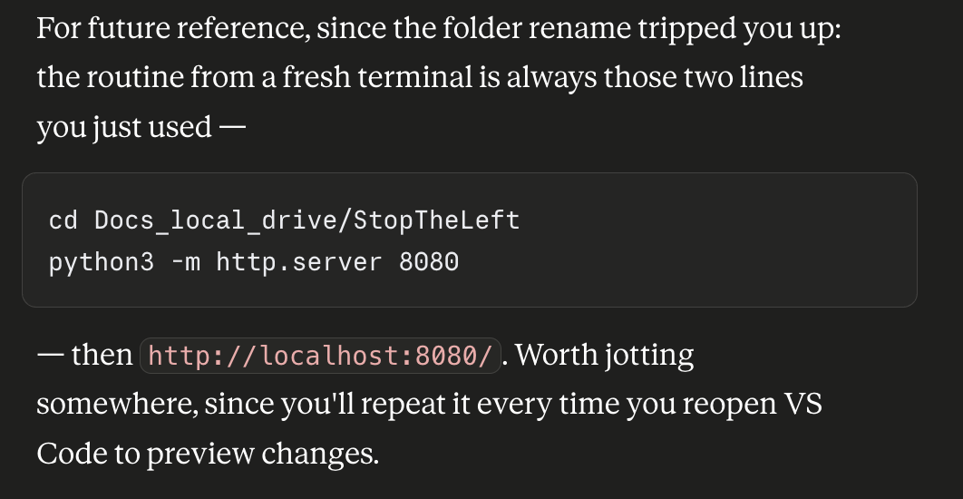

cd Docs_local_drive/StopTheLeft

Python3 -m http.server 8080

http://localhost:8080/

